Valentin Gnidyi BSCH4 – 23 Project Idea 1  
  
Creating a Local Artisan Marketplace app

Supporting local businesses and promote unique, handmade products. Here's a breakdown of features for both artisans and buyers:  
  
Artisan Interface:

**Artisan Profile Creation:**  
Allow artisans to create profiles showcasing their work, including a portfolio of products, descriptions, pricing, and contact information.

**Product Listings:**  
  
Enable artisans to upload images and details of their products, including categories such as handmade crafts, artwork, jewelry, etc.

**Order Management:**  
  
Provide tools for artisans to manage orders, track shipments, and communicate with buyers. Include order history and status updates.

**Payment Processing:**  
Integrate a secure payment gateway to facilitate transactions. Support multiple payment methods, including credit cards and digital wallets.

**Promotion and Marketing Tools:**  
  
Include features for artisans to promote their products, such as discounts, limited-time offers, and social media sharing.

**Inventory Management:**  
Offer tools to manage inventory levels, automatically updating product availability based on sales.

Logistic and Delivery:

Give an option to use one of most popular tracking systems in Ireland and courier services, such as: DPD, UPS, An Post, FreeWay.

**Products Rating and Comments:**  
  
Allowing to leave the comments from other craft makers and customers.

**Artisan Community Forum:**  
  
Create a forum or community space where artisans can connect, share tips, and discuss their craft.

**Analytics Dashboard:**  
Provide analytics tools to help artisans track sales, and popular products.

Buyer Interface:

**Local Artisan Search:**  
Allow users to search for local artisans based on location, product category, or specific keywords.

**Product Reviews and Ratings:**  
Enable buyers to leave reviews and ratings for products.

**Secure Checkout:**  
Implement a secure and user-friendly checkout process, including the option for guest checkout and order tracking.

**Wishlist and Favorites:**  
Allow users to create wishlists and mark favorite products for easy future reference or sharing.

**Geolocation Services:**  
Implement geolocation services to show buyers artisans and products in their local area, encouraging support for nearby businesses.

**Notifications and Alerts:**  
Set up push notifications for users to receive updates on new products, promotions, or events from their favorite artisans.

**Community Events Listing board:**  
Include a Listing board of local artisan events, markets, or fairs to further engage buyers with the artisan community.

**Social Media Integration:**  
  
Allow users to share their purchases or desired product on social media platforms directly from the app, promoting the local artisan marketplace.

**Familiar Mobile applications existing on Play Store:**

Artisans Market   
  
Not available to users of Europe only for the South Africa  
  
<https://play.google.com/store/apps/details?id=com.designodyssey.artisansmarket&hl=en_IE&gl=US>

The application having familiar concept of the developed application however. Without social iterations and representation of platform for community and craft sharing ideas. Available to use only in South Africa region, and not accessible for users from Europe Region.

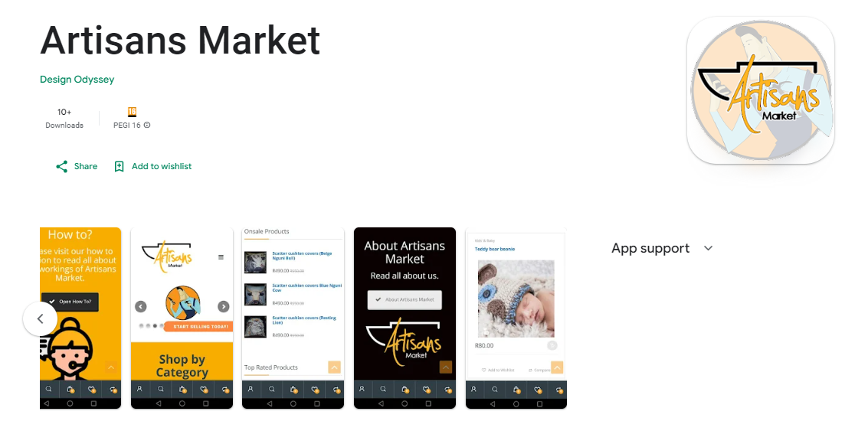

Application Fundctionality:

Creating Artisan`s account;

Shop statistics;

Connecting to the location area;  
Order Management;

Sales and upselling techniques;

Separating product in categories.   
Creating wish lists.

History of purchase.  
Checkout.

Functionalities that are missing:   
NO inventory management;  
NO Community Forum;  
NO notifications or activity listing for favourite shop;

NO Community events listing.  
NO integration with Social Media.

The Web Application of Artisans market now is represented as Close store with option of custom design.   
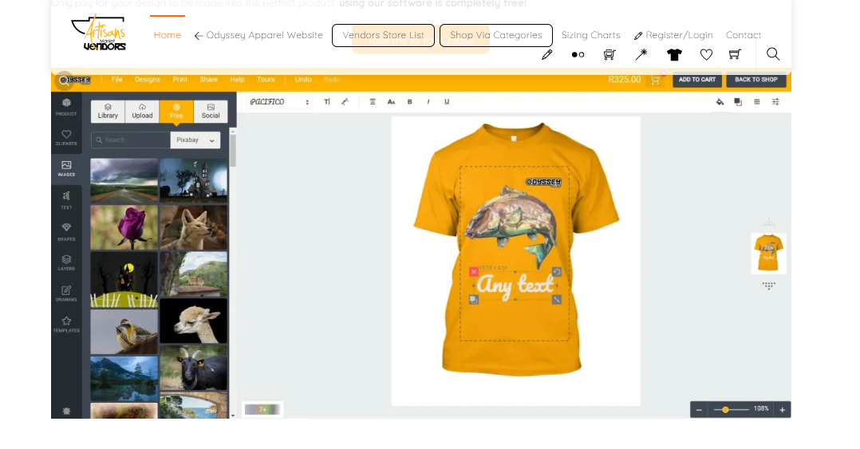

The Artisian:   
  
<https://play.google.com/store/apps/details?id=branded.m7af38079a9c3495c832a9d5163c17bea.mysite3&hl=en&gl=US>

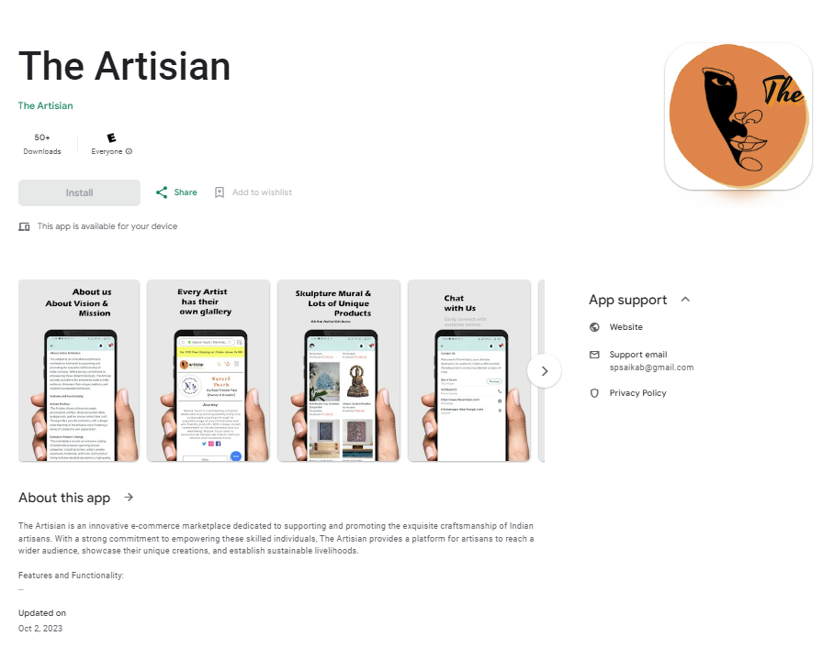

The Artisian

https://www.the-artisian.com/

India Focused Marketplace that available to be used as an mobile app world-wide. Payment and delivery accepting in Europe Region. Registrate can be only as buyer not artisan.

The functionality is described below:

Features and Functionality:  
  
1. Extensive Product Catalog: Filters are able to check the different products with different categories;

2. Secure Transactions: Able to use several payment methods or electronic wallets.  
3. Artisian Stories and Blogs: already created stores has a fulfilment of content, however the quantity of stores is very limited.   
  
4. Ratings and Reviews:

5. Seamless Logistics and Delivery: estimated delivery over the India is listed a for a couple of days.  
  
6. Sharing the product or order over social media.

Missing Features:   
No availability to Creating Artisan Profiles.

No Event Listing Board;

No availabilities to have a search by geolocation or showing the artisans near me.